LAB EXPERIMENTS CLOUD COMPUTING CSA1559
MAHESH R
192325019

EXP NO 1: Create a simple cloud software application for Flight Reservation System using
any Cloud Service Provider to demonstrate SaaS include the necessary fields
such as one way, round trip, From, to, Departure, Departure, Travelers & Class,
Fare Type, International and Domestic Flights etc.
DATE:
AIM:
To create a simple cloud software application and provide it as a service using
any cloud service provider todemonstrate software as a service (saas).
PROCEDURE:
STEP1: GOTO ZOHO.COM
STEP 2: LOGIN TO THE ZOHO.COM
STEP 3: SELECT ONE APPLICATION
STEP 4: ENTER APPLICATION NAME
STEP 5: CREATED NEW APPLICATION
STEP 6: SELECT ONE FORM
STEP 7: THE SOFTWARE HASE BEEN CREATED.

IMPLEMENTATION:
STEP1: GOTO ZOHO.COM
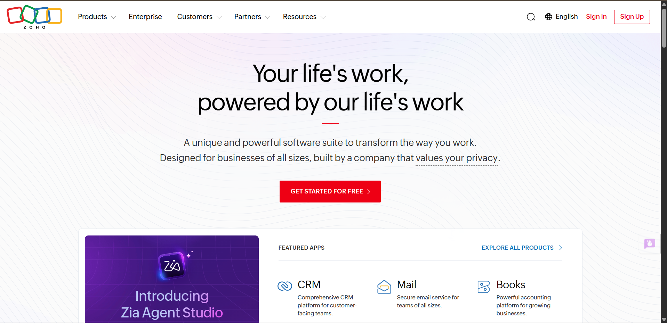
Step 2:Search for creator
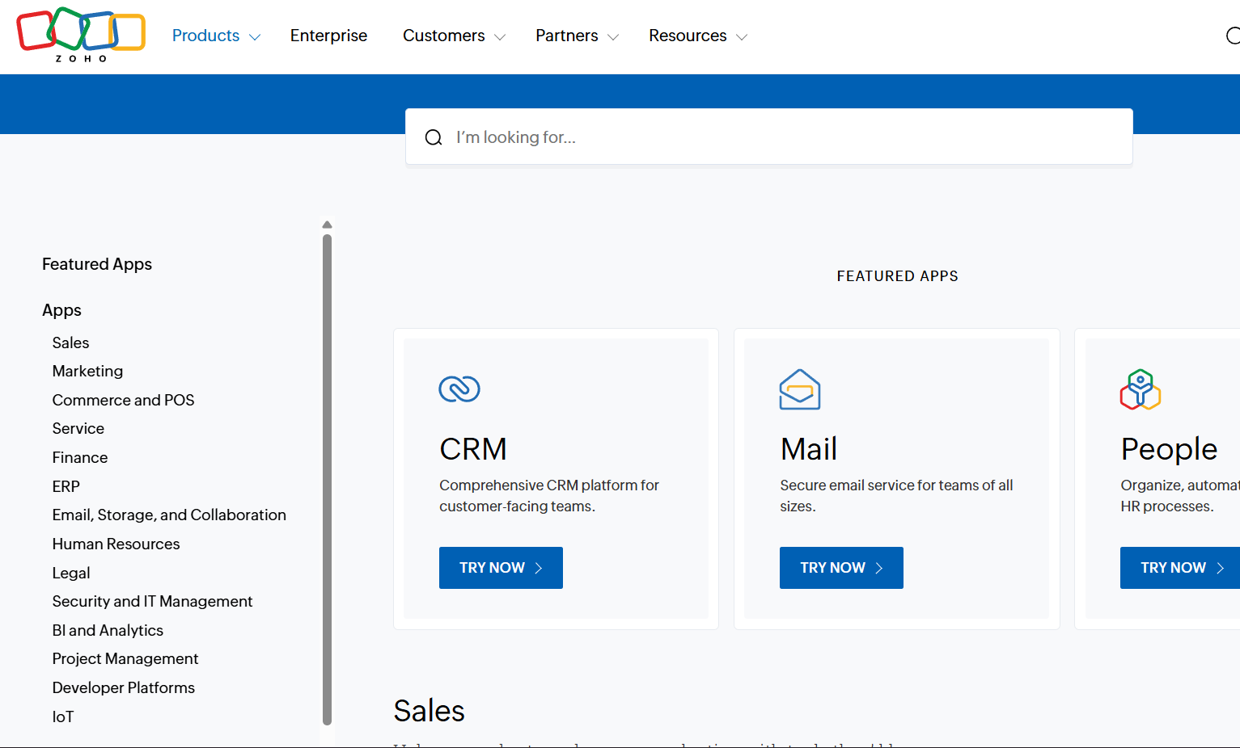
Step 3: give the prompt for your application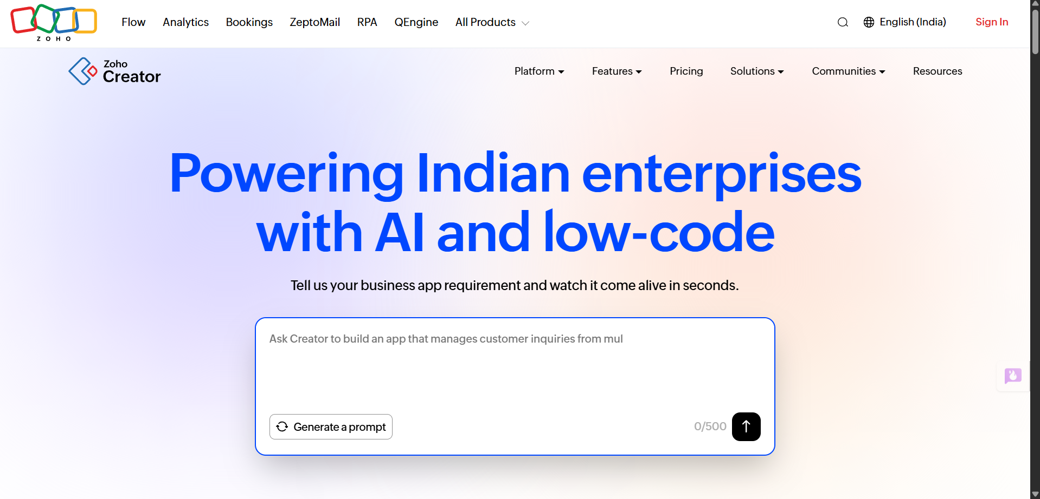

Step 4:click on create application
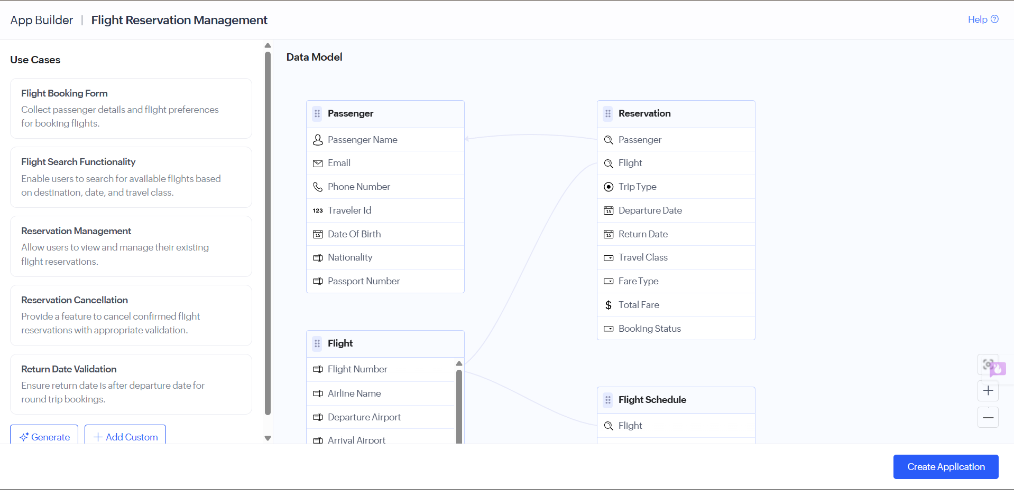
Step 5: application has successfully created.
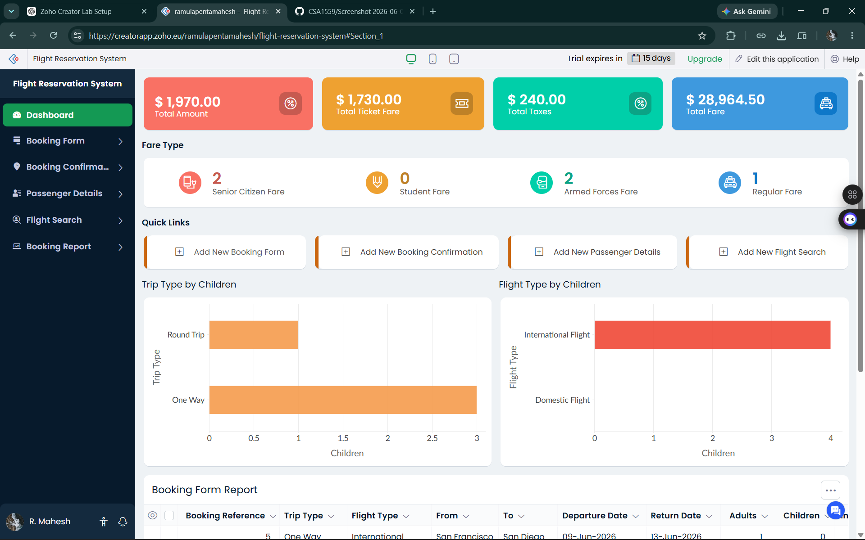
EXP NO 2: Create a Property Buying and Rental Management System for Chennai. Include fields: Customer Name, Phone, Email, Property Type (Residential/Commercial), Transaction Type (Buy/Rent), Area, Place, Property Size, Property Value, Rent Range, Rental Agreement Number, Agreement Start Date, Agreement End Date, Owner Name, Property Status, and Remarks. Add features for Search Property, Buy Property, Rent Property, View Agreements, Reports, and Dashboard.
DATE:
AIM:
To create a simple cloud software application for Property Buying and Rental Management system using
any cloud service provider to demonstrate saas.
PROCEDURE:
step1: Go to zoho.com.
STEP1: GOTO ZOHO.COM

Step 2:Search for creator

Step 3: give the prompt for your application

Step 4:click on create application and create from scartch
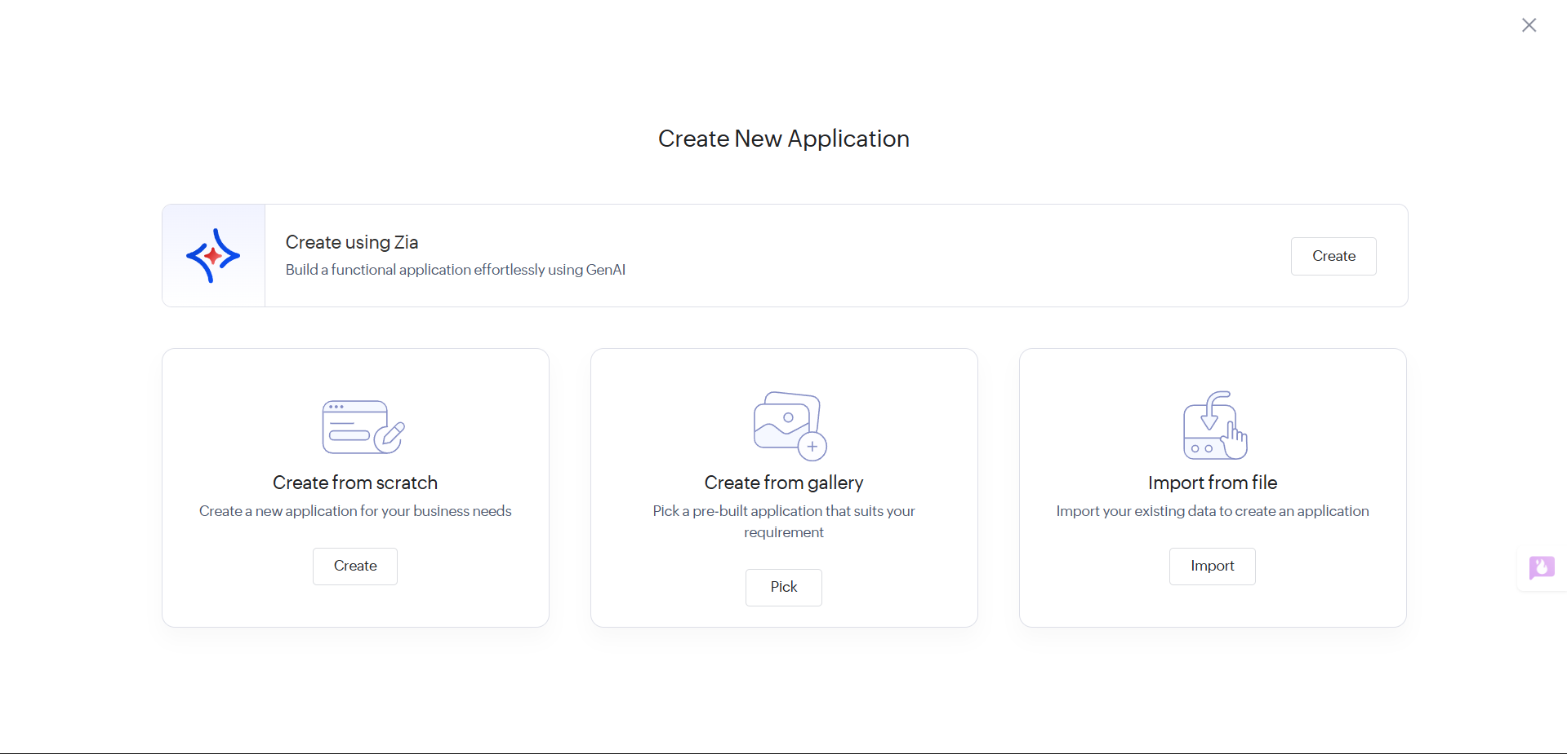
Step 5: click on create application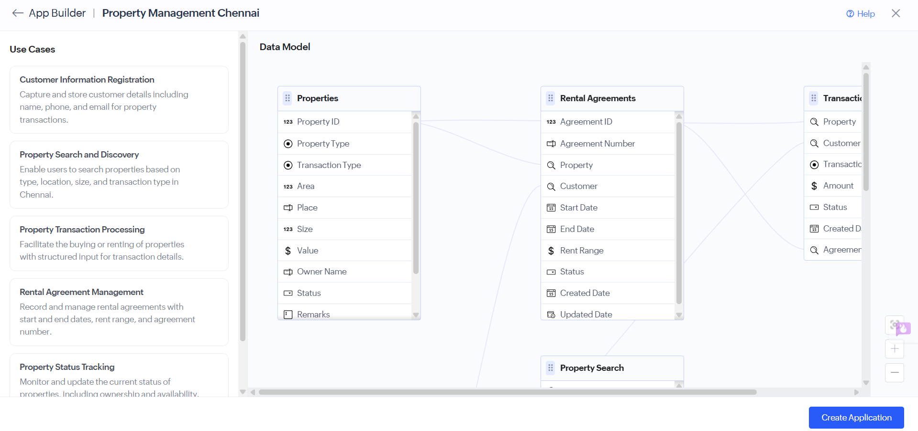

Step 6: software has sucessfully created.
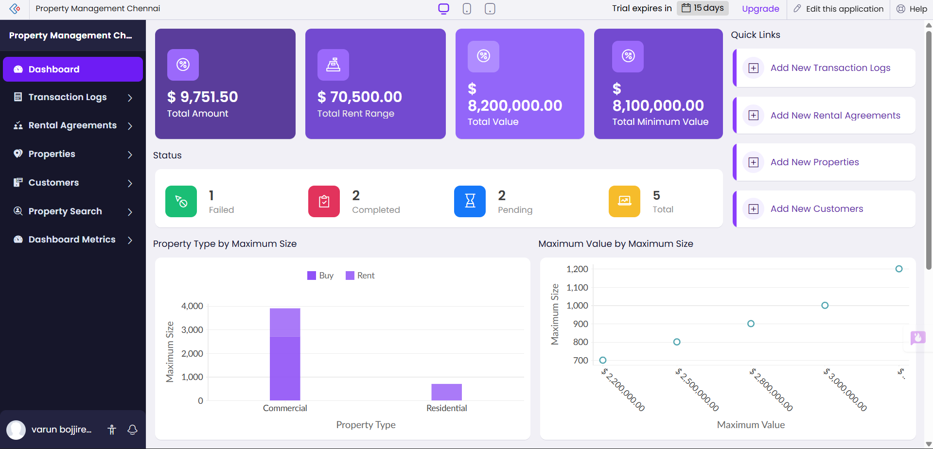
EXP NO 3 Create a simple cloud software application for Car Booking Reservation System
using any Cloud Service Provider to demonstrate SaaS include the necessary
fields such as search for cabs, from, to, rental , out station, Package type,
hours/Days etc.
DATE:
AIM:
To create a simple cloud software application for Car Booking Reservation system using
any cloud service provider to demonstrate saas.
PROCEDURE:
step1: Go to zoho.com.
STEP1: GOTO ZOHO.COM

Step 2:Search for creator

Step 3: give the prompt for your application

Step 4:click on create application and create from scartch

Step 5: click on create application
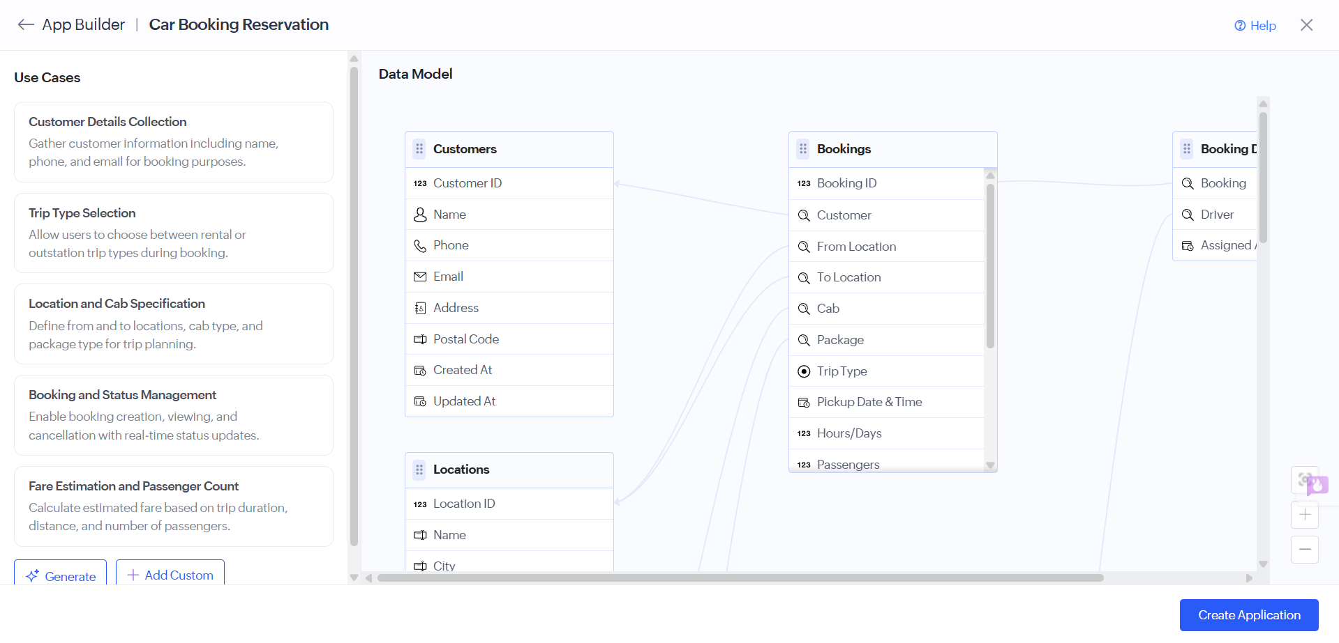

Step 6: software has sucessfully created.
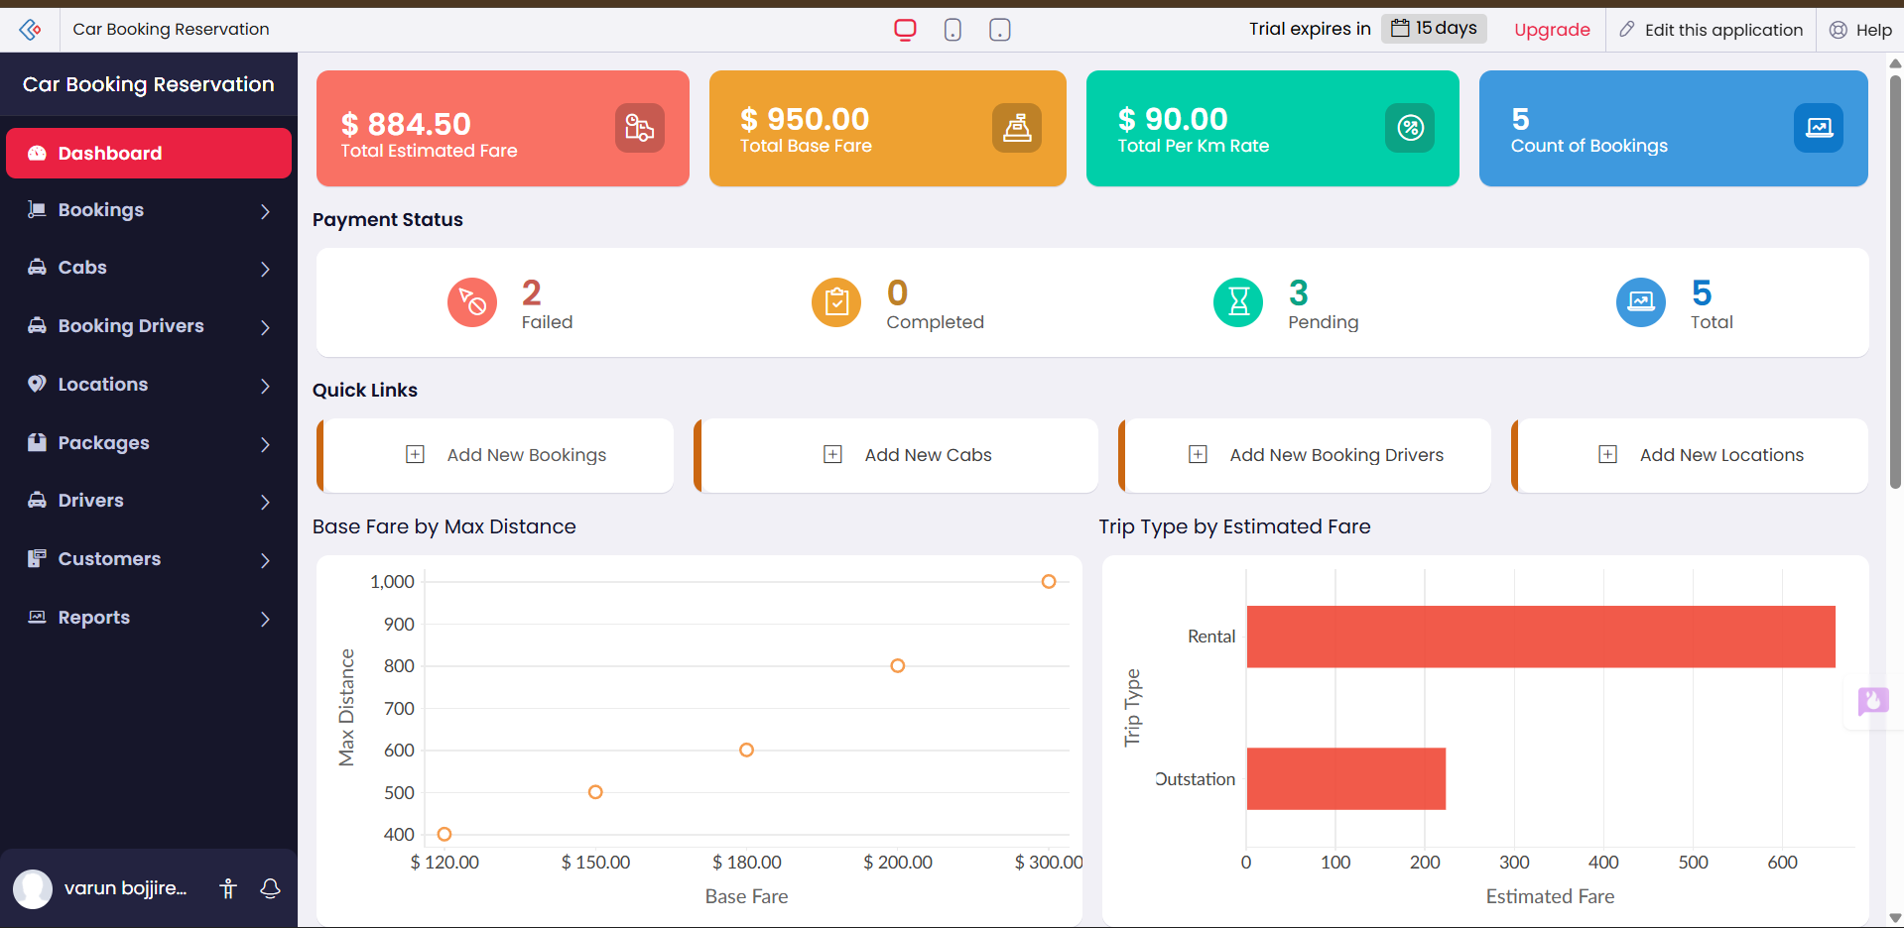
EXP NO 4 Create a simple cloud software application for Library book reservation system
for SIMATS library using any Cloud Service Provider to demonstrate SaaS
include the necessary fields such as Title of the book, author, publications,
Year, edition, no of copies, Rack no, status (taken/returned) etc.
DATE:
AIM:
To create a simple cloud software application for Library book reservation system using
any cloud service provider to demonstrate saas.
PROCEDURE:
step1: Go to zoho.com.
STEP1: GOTO ZOHO.COM

Step 2:Search for creator

Step 3: give the prompt for your application

Step 4:click on create application and create from scartch

Step 5: click on create application
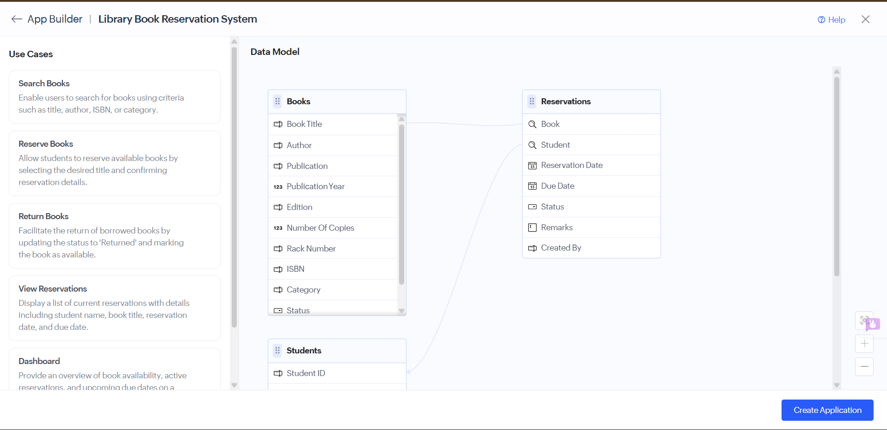

Step 6: software has sucessfully created.
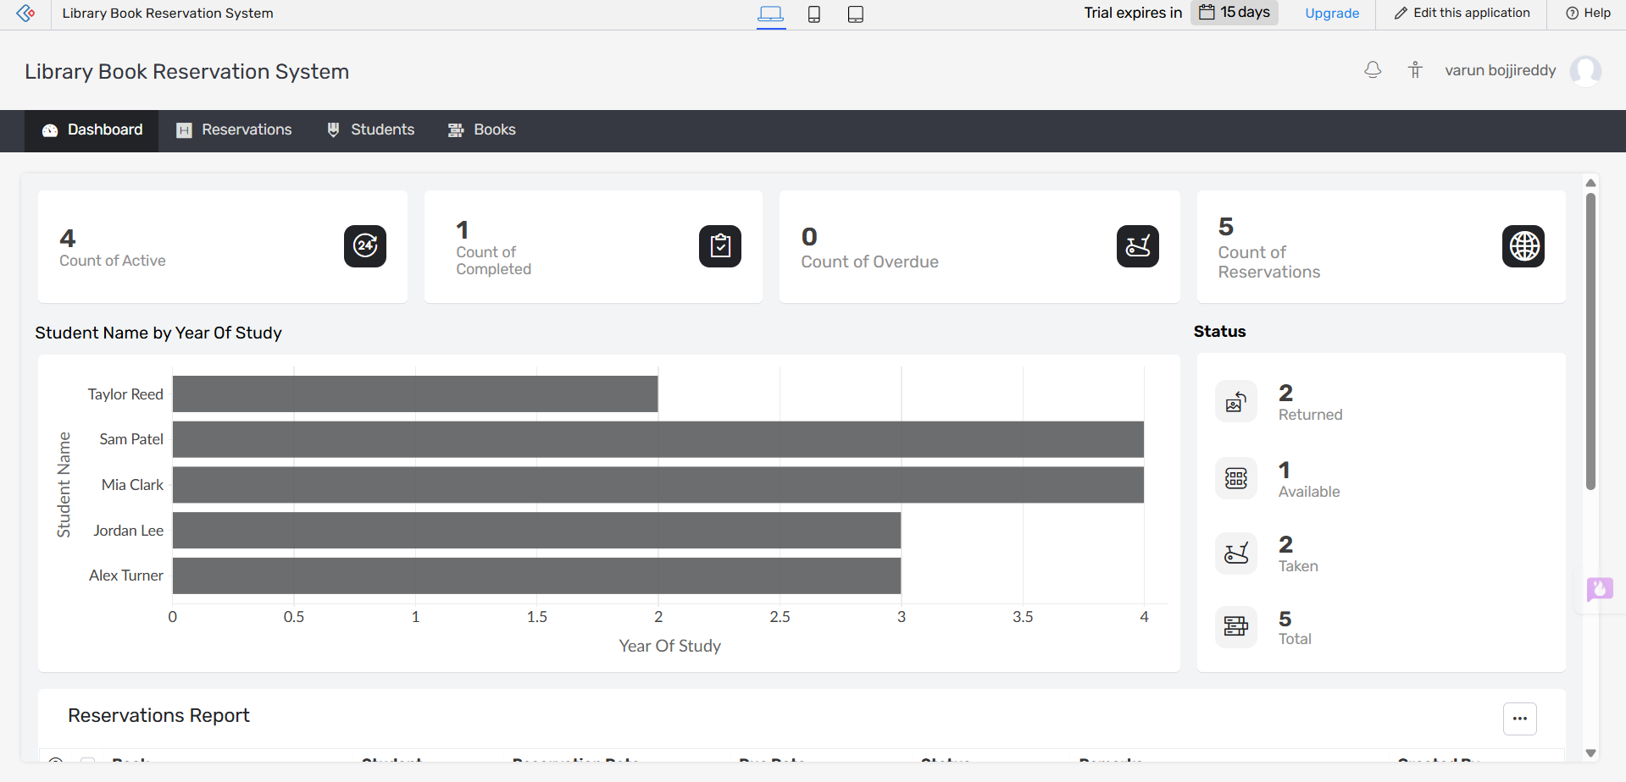

EXP NO 5 Create a simple cloud software application for Mark Sheet Processing System
using any Cloud Service Provider to demonstrate SaaS include the necessary
fields such as name of the student, Reg no of the student, Subjects , Marks,
Average, percentage, rank, overall performance etc.
DATE:
AIM:
To create a simple cloud software application for Mark Sheet Processing System using
any cloud service provider to demonstrate saas.
PROCEDURE:
step1: Go to zoho.com.
STEP1: GOTO ZOHO.COM
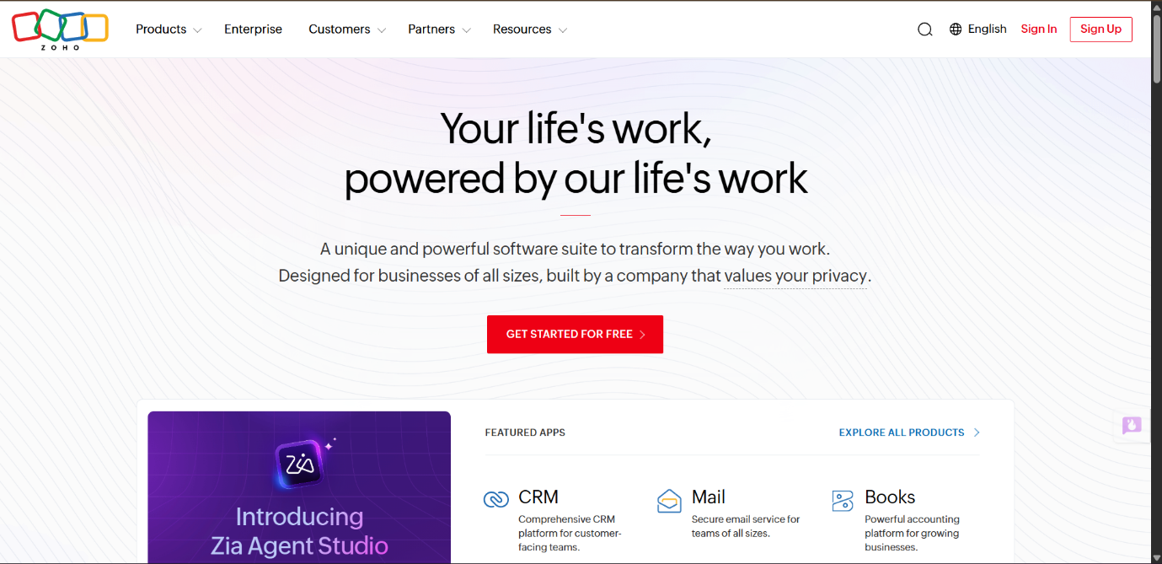
Step 2:Search for creator

Step 3: give the prompt for your application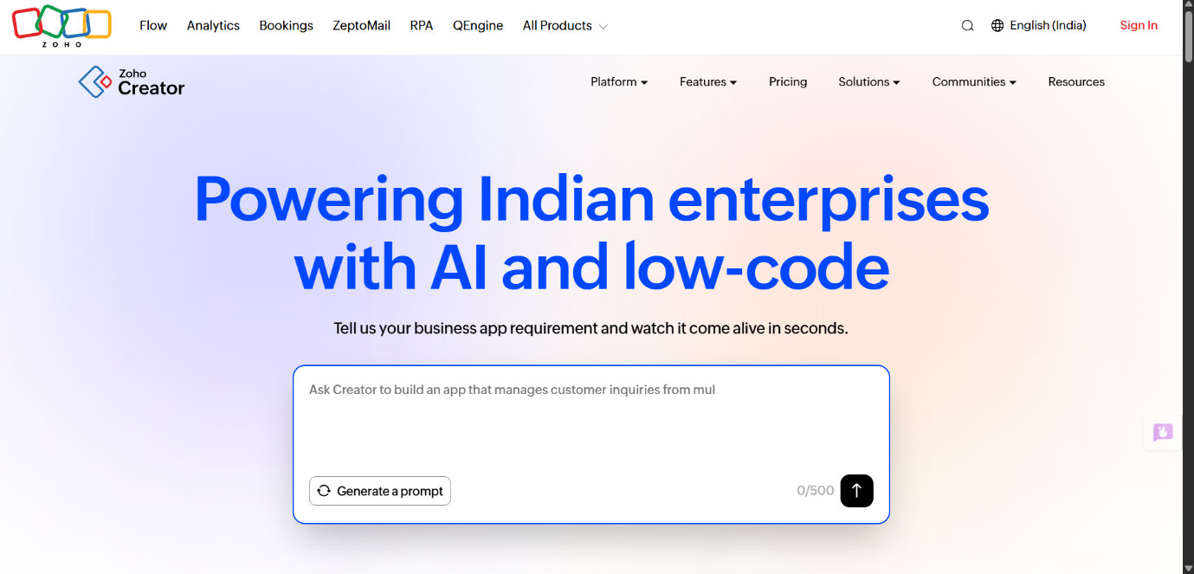

Step 4:click on create application and create from scartch
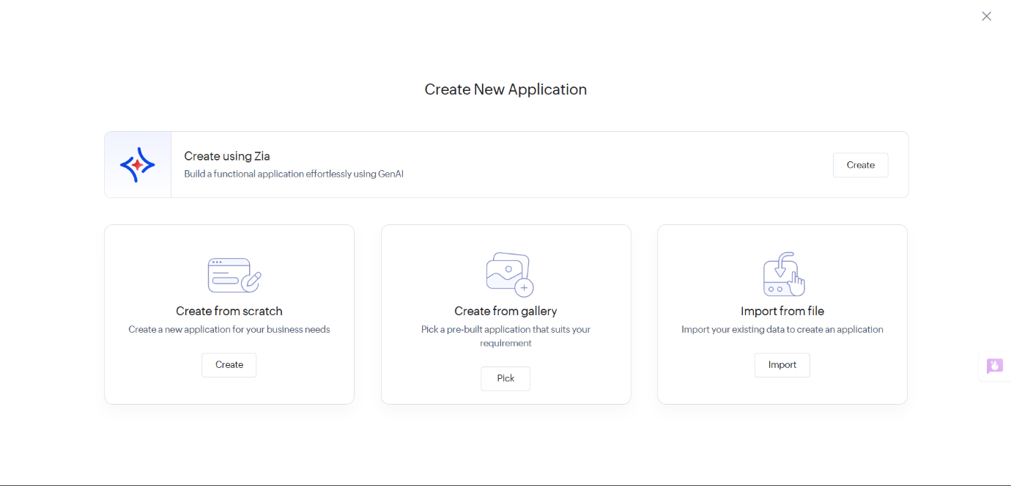
Step 5: click on create application
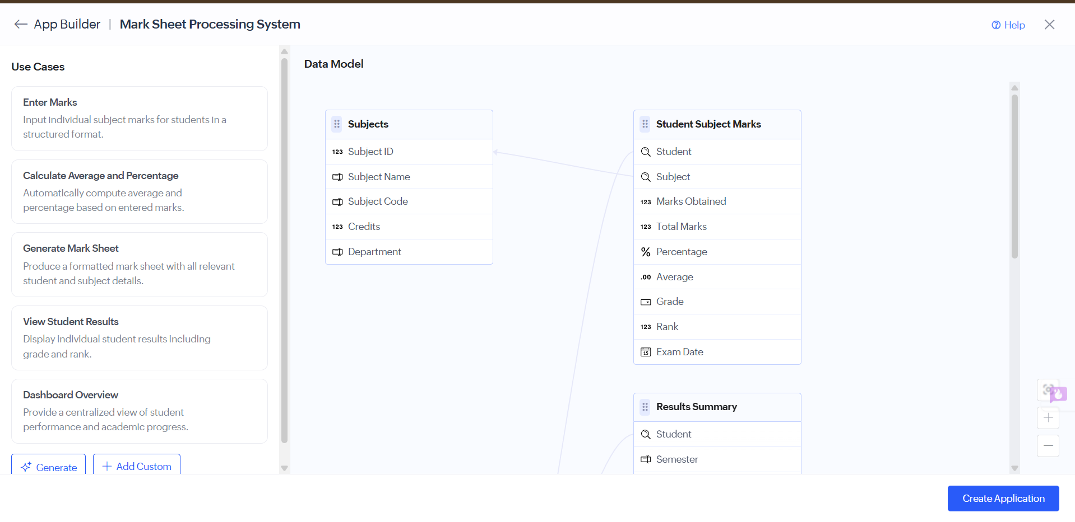

Step 6: software has sucessfully created.
